Year 4 Spring 2024 Coverage Map
Spring 1 (6 weeks) |  |  | Spring 2 (6 weeks)
Explorers:  Being resilient: I know not to just dwell on the negatives but look at the positives too | Explorers:  Being resilient: I know not to just dwell on the negatives but look at the positives too | Explorers:  Being resilient: I know not to just dwell on the negatives but look at the positives too | Expression: | Expression:
Science: (3 weeks):  Enquiry question: How can I investigate light, sound and electricity when they are invisible?  Outcome: Create a journal page to explain light and sound (including electricity). | Design and Technology (2 weeks):  Enquiry question: How can I use plan-do-review to improve my design?  Outcome: To produce a prototype from a design brief | Poetry (1 week):  Enquiry question: How did William Blake create an image for The Tyger?  Outcome: To write a poem in the style of William Blake. | History (3 weeks)  Enquiry Question: How did William I conquer England?  Outcome: To write an information text about the impact the Battle of Hastings. | Religious Education (3 weeks)  Enquiry Question: How do stories and symbolism explain the beliefs of Hinduism?  Outcome: Create an information text about stories and symbolism within the Hinduism.
Substantive Knowledge  In order to see things, there must be light  Dark is the absence of light  What reflection is (mirrors change direction of light)  That sounds are made from vibrations  Sounds travel through a medium to the ear (air, vacuum)  That objects make different sounds and pitches (nature, people, animals)  The relationship between volume of a sound and strength of a vibration  ELECTRICITY  Common appliances that run on electricity  How to complete a simple electrical circuit which includes cells, switches, wires and buzzers  If a lamp will light up or not dependent on the circuit  Which materials make good conductors and insulators (insulators- plastic, wood and rubber. Conductors – silver, gold, metal and sea waves | Substantive Knowledge  • Where products may have been made.  • When products might have been designed and made.  • What a prototype is and how to use them.  • The functions of different tools and how to use them.  • How to apply different finishing techniques to preserve and decorate.  • How to identify products that can be recycled or reused. | Substantive Knowledge  To recognise and discuss some different forms of poetry (e.g. free verse or narrative poetry).  To prepare and perform poems and play scripts with appropriate techniques (intonation, tone, volume and action) to show awareness of the audience when reading aloud. | Substantive Knowledge  VIKING RAIDS AND SAXON SETTLEMENTS  • What a millennium is and that things can change over time  • Why people did things and what happened as a result e.g Anglo Saxon invasion, King Alfred’s impact, Battle of Hastings,  • That religion can influence results in history e.g Anglo Saxon Pagan Sutton Hoo, Pope Gregory and Christianity came to Britain  • Why raids happened e.g rob monasteries of gold and take people as slaves. Mostly in the summer due to weather.  • What caused conflict e.g Anglo Saxons and Vikings: Battle of Edington, Maldon and Assandun.  •• I can talk about a significant person of this time e.g Alfred the Great | Substantive Knowledge  2.7 What do Hindus believe God is like?  L2.8 What does it mean to be Hindu in Britain today?  What is Hinduism?  What are the similarities and differences between Hinduism and Christianity?
Disciplinary Skills  Investigating and hypothesising  Plan an investigation that demonstrates how I have considered the need for the test to fair and unbiased.  Say 2 reasons why my test is fair.  Say what I am trying to prove or disprove and how my test will help me do this in a fair way  Observing and recording  Design a table or chart that enables me to display my data collected in the most informative way.  Concluding and evaluating  Explain how the conclusion of my investigation relates to my hypothesis.  Articulate my hypothesis prior to designing my investigation  Identify where there might be anomalies  Evaluate the results of my Investigation and explain why they are not biased  Use my results to prove or disprove the hypothesis using a balanced argument | Disciplinary Skills  • Explain my design features  • Start to form a design  • Explain my choice of  materials and components  • Refer back to my design criteria  • Say how well I did | Disciplinary Skills  • To prepare and perform poems and play scripts that show some awareness of the audience when reading aloud.  • To begin to use appropriate intonation and volume when reading aloud. | Disciplinary Skills  • Use a wide variety of primary and secondary sources to support my enquiry including my notes from visits to sites of historical significance.  • Talk about how people’s lives in the past were different to our lives today and the reasons for this.  • Talk about the differences between primary and secondary sources and how they support an enquiry.  Interpret  • Look at two versions of the same event and identify the similarities and differences of the accounts.  • Give reasons why there might be different accounts of history.  • Understand that the past has been represented in different ways and give some examples of this.  • Look at two versions of the same account and say where they are similar and where they are different and explain why this might be.  Communicate  • Talk about chronology using words associate with time. E.g Millennium, monarchy  • Discuss dates and times accuracy and place key events on a timeline including Vikings, Tudors, Stone age, Romans, Their own life and an event n locality History.  • Use a wide range of historical vocabulary taken from the ACE list | Disciplinary Skills  *Recognise how and why sources of authority (e.g. texts, teachings, traditions, leaders) are used, expressed and interpreted in different ways, developing skills of interpretation  *Make connections between religious and non-religious beliefs, concepts, practices and ideas studied  *Evaluate, reflect on and enquire into key concepts and questions studied, responding thoughtfully and creatively, giving good reasons for their responses
Reading Objectives:  To check the meaning of words in a dictionary.  To use all of the organisation devices available in a non-fiction text to retrieve, record and discuss information. | Reading Objectives:  To check the meaning of words in a dictionary. | Reading Objectives:  To recognise and discuss some different forms of poetry (e.g. free verse or narrative poetry).  To prepare and perform poems and play scripts with appropriate techniques (intonation, tone, volume and action) to show awareness of the audience when reading aloud. | Reading Objectives  To refer to authorial style, overall themes (e.g. triumph of good over evil) and features (e.g. greeting in letters, a diary written in the first person or the use of presentational devices such as numbering and headings). | Reading Objectives  To identify how language, structure and presentation contribute to meaning.  To identify main ideas drawn from more than one paragraph and summarise these.
Writing Objectives:  • Consistently organise their writing into paragraphs around a theme to add cohesion and to aid the reader.  •Write a range of narratives and nonfiction pieces using a consistent and appropriate structure (including genre specific layout devices e.g.: text boxes, bullet points etc.)  • Use subordinate clauses, extending the range of sentences with more than one clause by using a wider range of conjunctions, which are sometimes in varied positions within sentences. | Writing Objectives:  Consistently use apostrophes for the singular and plural possession  Use of demonstrative determiners ‘this, those, these, that’ | Writing Objectives:  •Use Standard English verb inflections accurately, e.g. ‘we were’ rather than ‘we was’ and ‘I did’ rather than ‘I done’. | Writing Objectives  Use superlatives and comparatives  Use relative pronouns which or who to make an imbedded clause a complex sentence | Writing Objectives  Use subordinate clauses, extending the range of sentences with more than one clause by using a wider range of conjunctions, which are sometimes in varied positions within sentences.  Use all the necessary punctuation in direct speech, including a comma after the reporting clause and all end punctuation within the inverted commas
Metacognitive Tool:  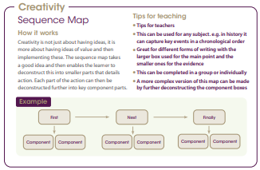 | Metacognitive Tool:  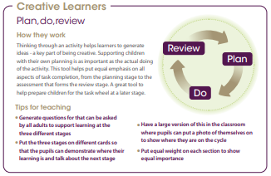 | Metacognitive Tool:  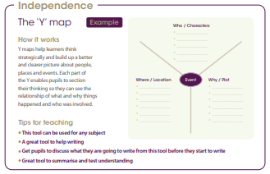 | Metacognitive Tool: | Metacognitive Tool:
Relationships Education:  Do we have to play with the same people every day?  Can we have more than one group of friends? | Relationships Education:  Do we have to be friends with everyone?  How can we respect people’s friendships? | Relationships Education:  What does respect look like online? https://www.youtube.com/watch?v=mZtXwLzlIpk  How can we be respectful online?  How can we be kind online?  What could happen if we are unkind online? | Relationships Education:  What does a best friend look like? | Relationships Education:  How can we manage different friendships?
Fiction and non-fiction texts that will be shared with children:  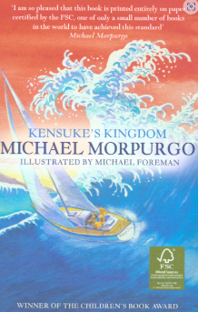  Kensuke’s Kingdom | Fiction and non-fiction texts that will be shared with children:  Kensuke’s Kingdom | Fiction and non-fiction texts that will be shared with children:  Kensuke’s Kingdom | Fiction and non-fiction texts that will be shared with children:  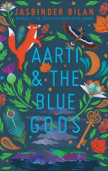  Aarti and the Blue Gods | Fiction and non-fiction texts that will be shared with children:  Aarti and the Blue Gods

