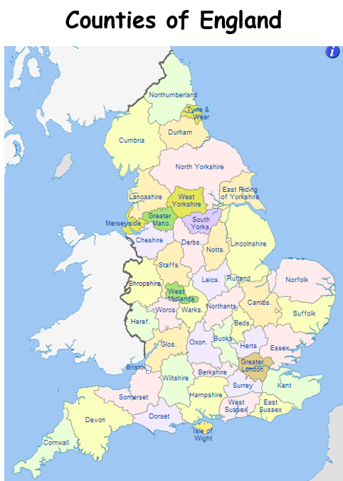

**Vocabulary**

river

factory

farm

human

physical

coast

countryside

rural

urban

district

forest

moorland

mountains

city

county

borough

county

**Year 2 – Summer 1**

**Geography**

Knowledge Organiser

