**London or Shaldon: Where would I prefer to live when I grow up?**

What does a geographer do?

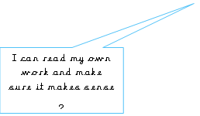S I can explain my choices **(Responsibility)**



I can step up to meet a challenge **(Courage)**

I can explain my choices **(Responsibility)**

I can step up to meet a challenge **(Courage)**



What is fieldwork?

What do I remember about Shaldon?



**Week 1**

I can identify how two pictures look different?

I can add and, but, so into my sentence.

How do I use a compass?

What are Shaldon’s features?

What are the natural and human-made features in my area?





**Week 2**

I can create a map of my local area?

What makes London a city?



I can create a fact-file about London?

Where is London?



**Week 3**

I can identify similarities and differences between Shaldon and London?



**Flourishing**

I can explain my choices **(Responsibility).** I can step up to meet a challenge **(Courage).**

I can articulate my ideas to the class.

I can extend my sentences in my speech using; and, but, because, so.

I can give feedback to friends respectfully.

I can choose appropriate voice choice.