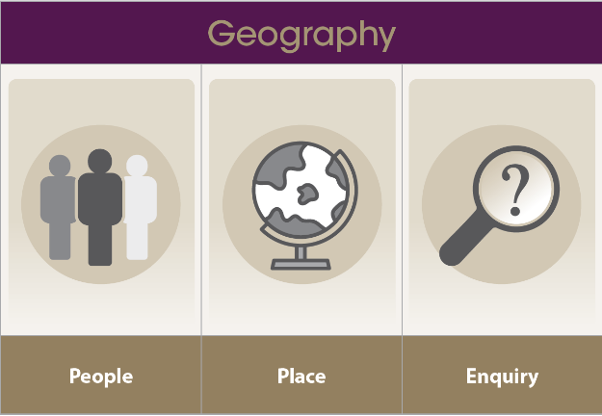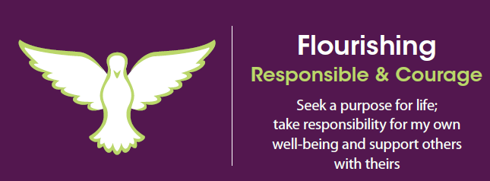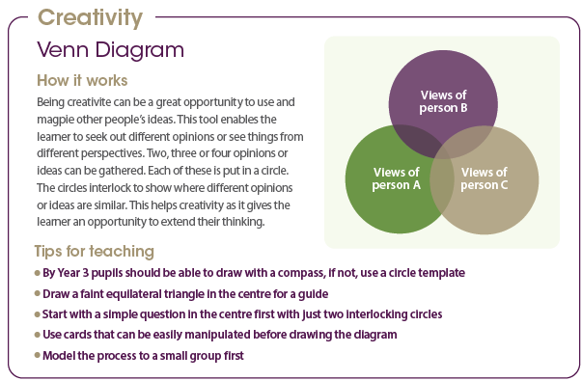

**Flourishing**

Responsible

• I know my choices are important and have outcomes

• I can explain the outcomes of my choices

• I can tell you where I took responsibility for my learning

Courage

• I can show I can step up to meet a challenge

• I know what it is to be brave and show this by trying new things

• I have a go at new learning even though I know I might be wrong

**Creativity**

We will be using the Venn Diagram thinking tool to compare counties, looking at how they are similar and how they are different.

**Knowledge**

• Where the United Kingdom is on a map.

• What the countries of the United Kingdom are.

• Some of the major cities and rivers of the UK, including capital cities.

• Human and physical features of different counties.

• What Nationality means.

**Skills**

• Give simple descriptions of geographical features and how these differ between counties.

• Ask geographical questions and find answers to these.

• Use a compass to give directions using 4 points

**Developing my geography**

**Outcome:** To write an information page about the counties of the UK.

**Developing as a learner**

**Developing my character**

**How is the UK like a giant jigsaw puzzle?**